**Assigning Permissions to Managed Identity**

**Work done by**: Jilani and Irshad

**Source:** [**https://learn.microsoft.com/en-us/azure/automation/learn/automation-tutorial-runbook-textual**](https://learn.microsoft.com/en-us/azure/automation/learn/automation-tutorial-runbook-textual)

**Prerequisites:**

**1.**An Azure Automation account with active subscription

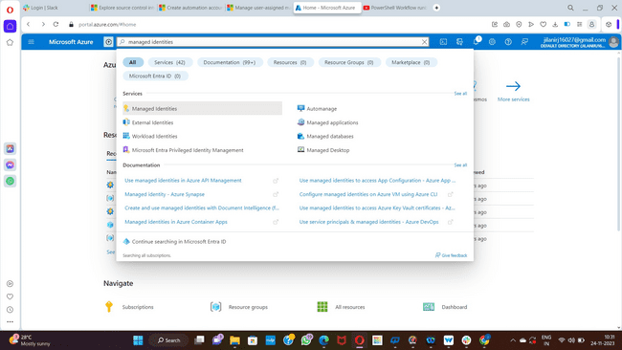



1. **Sign in to the**[**Azure portal**](https://portal.azure.com/)**and navigate to your Automation account.**
2. **Under Account Settings, select Identity (Preview).**
3. **From the System assigned tab, under Permissions, select Azure role assignments to open the Azure role assignments page**

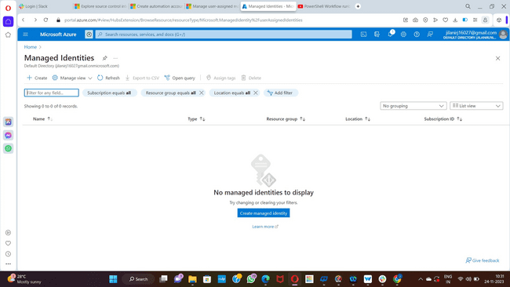



**Now click on Create Managed identity.**

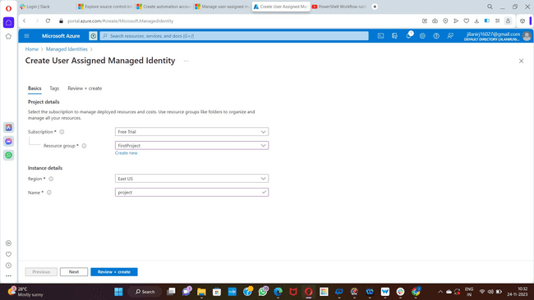



**Give subscription as free trial and select resource group if you don’t have a resource group then create one, select region and give name and then click on review and create.**

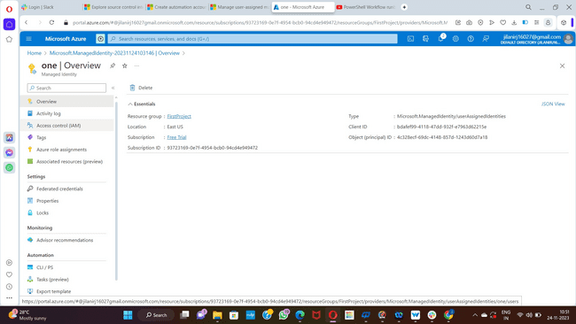



**You will be redirected to this page from here select IAM which is present at the left corner.**

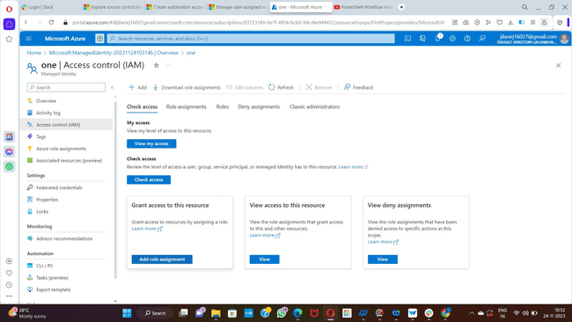



**Click on Role assignment.**

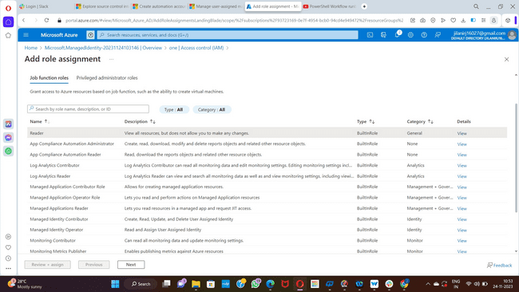



**From here select the job function role you want to assign to the member and click on next**

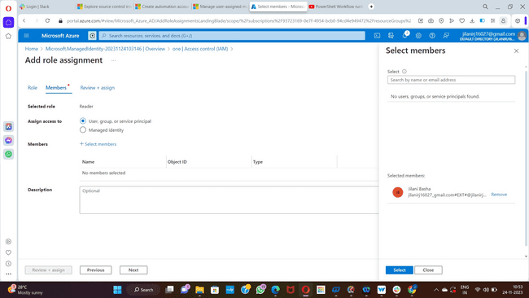



**Now select the member for the job function role. By clicking on select member**

**Add the member and click on select**

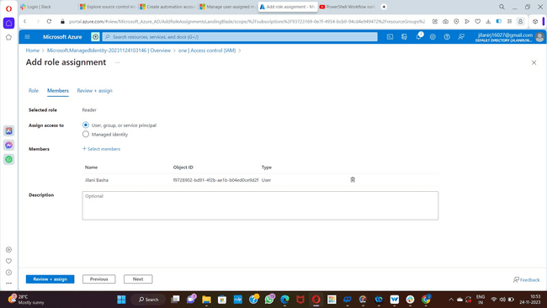



**Here you can see that a member is added for that job function role,**

**Now click on review and assign**

**So in this way we can assign a managed identity(to assign a job function role to particular member so that he can do that job only.)**